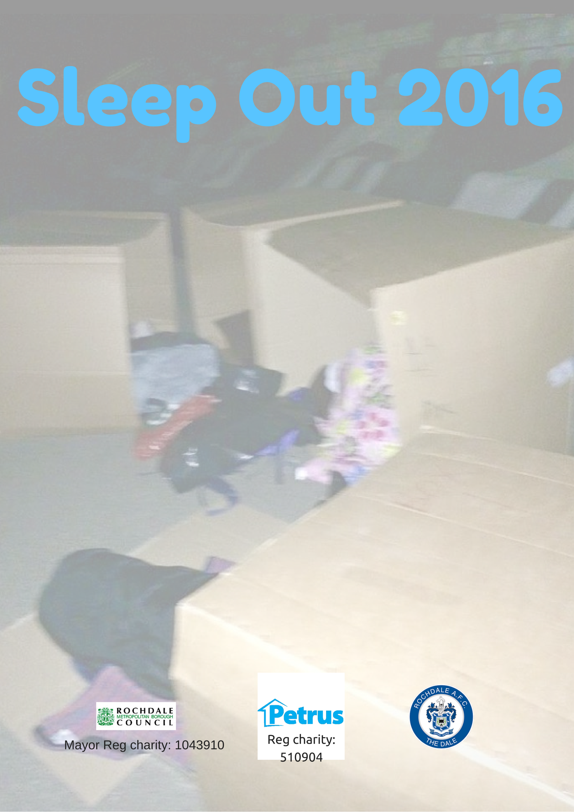

Registration Form
Name: ………………………………………………………………………..
Contact telephone number………………………………………..
Address………………………………………………………………………
…………………………………………………………………………………..
………………………………………………………………………………….
Email Address……………………………………………………………
Known medical conditions/needs……………………………..
………………………………………………………………………………..
D.O.B………………………………………………………………………..
Emergency contact name/Tel & address…………………...
…………………………………………………………………………………
…………………………………………………………………………………..
Personal sponsorship target………………………………………..
Please return this form to Craig Lee House, 25 church Lane, Rochdale OL16 1NR or email directly to sonia.denham@petrus.org.uk to confirm your registration for the event.

