Rochdale Borough Design Awards 2013
INFORMATION AND NOMINATION FORM

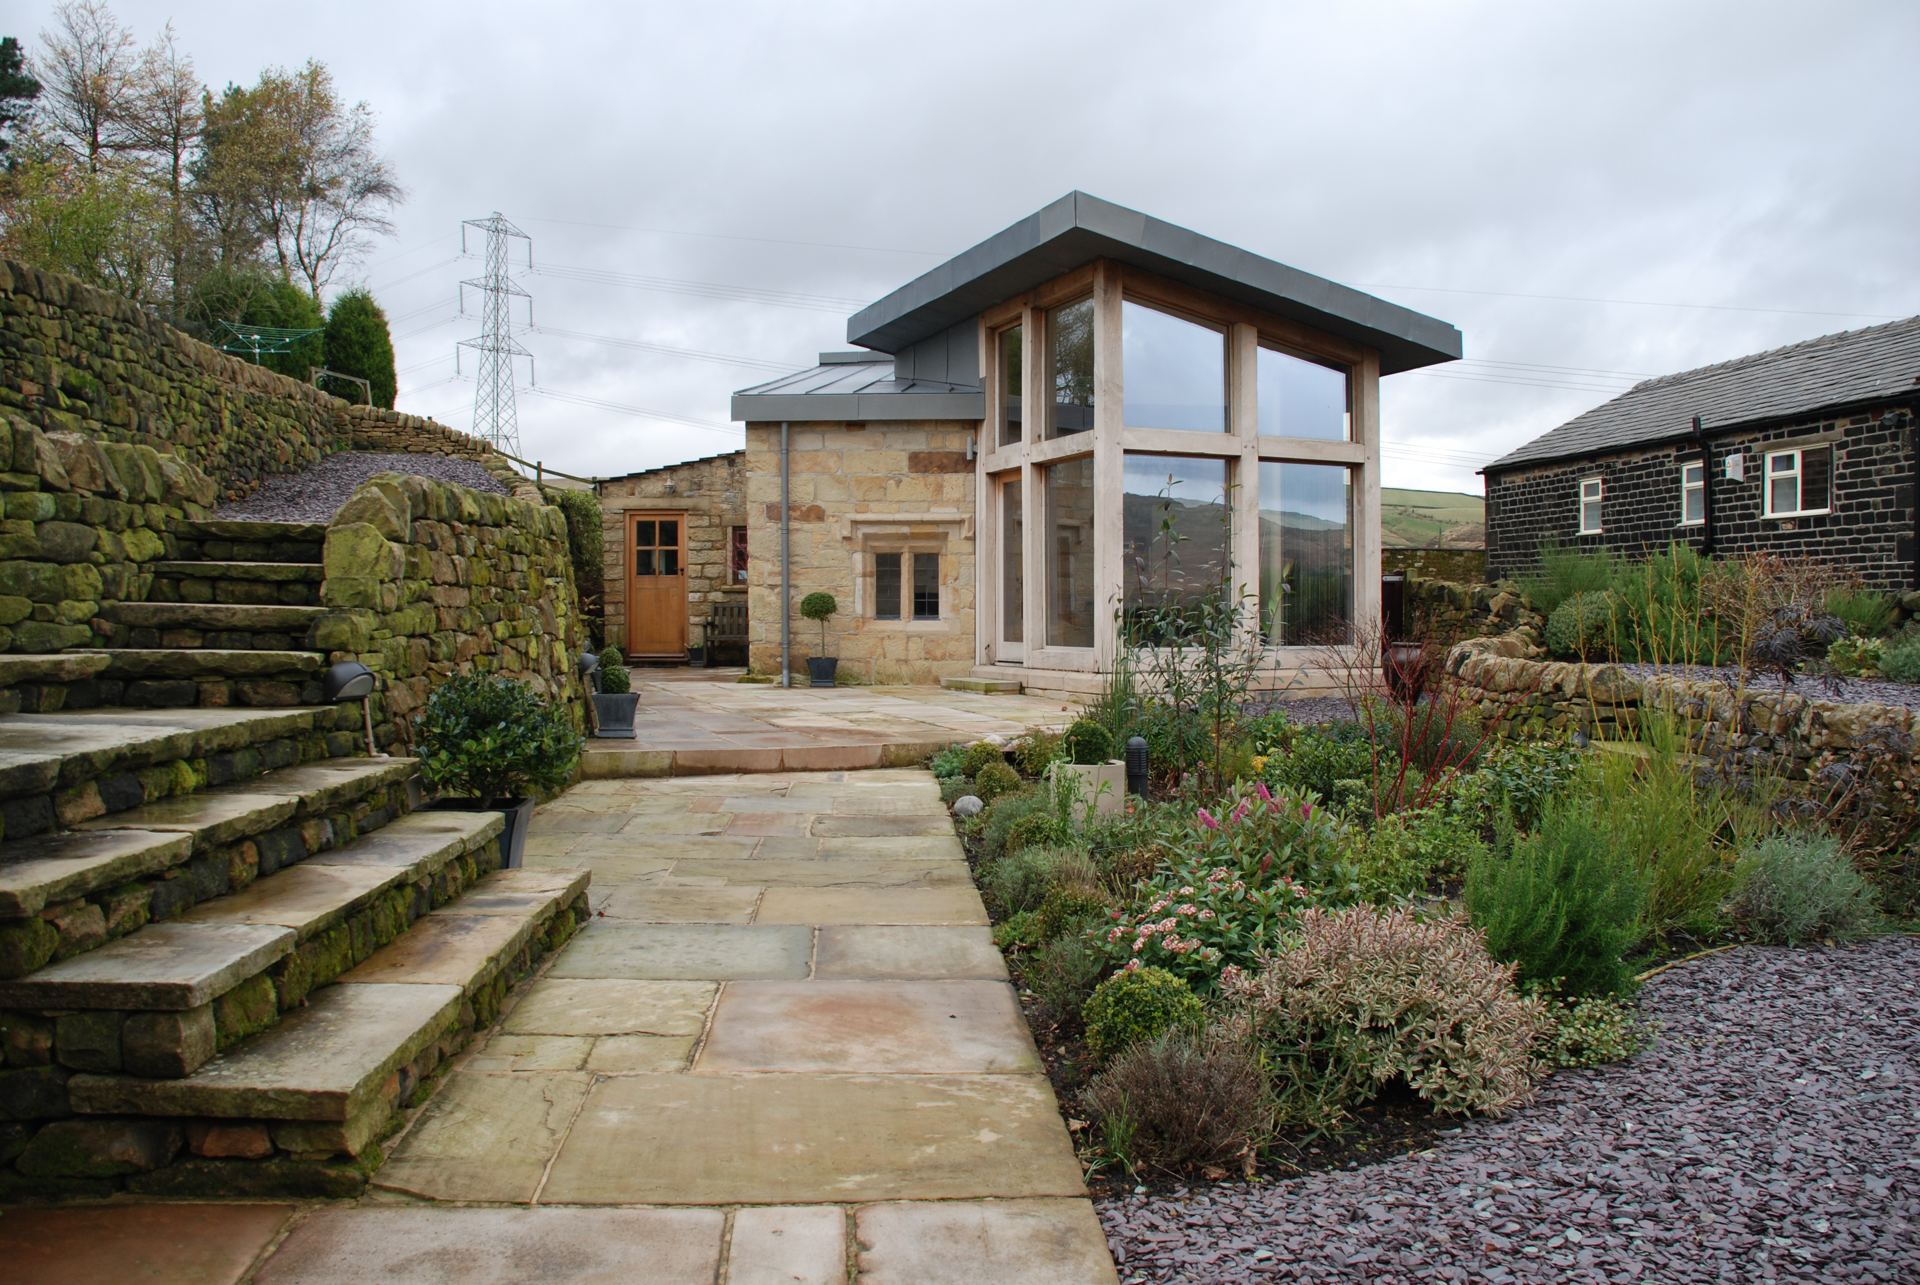
As part of Rochdale Borough Council’s commitment to, and recognition of, design excellence for new development, the Rochdale Borough Design Awards are held on an annual basis.

There are three awards – the Rochdale Borough Design Award and the Sustainable Development Award, decided by a panel of experts, and the Rochdale Borough People’s Design Award, decided by a public vote.

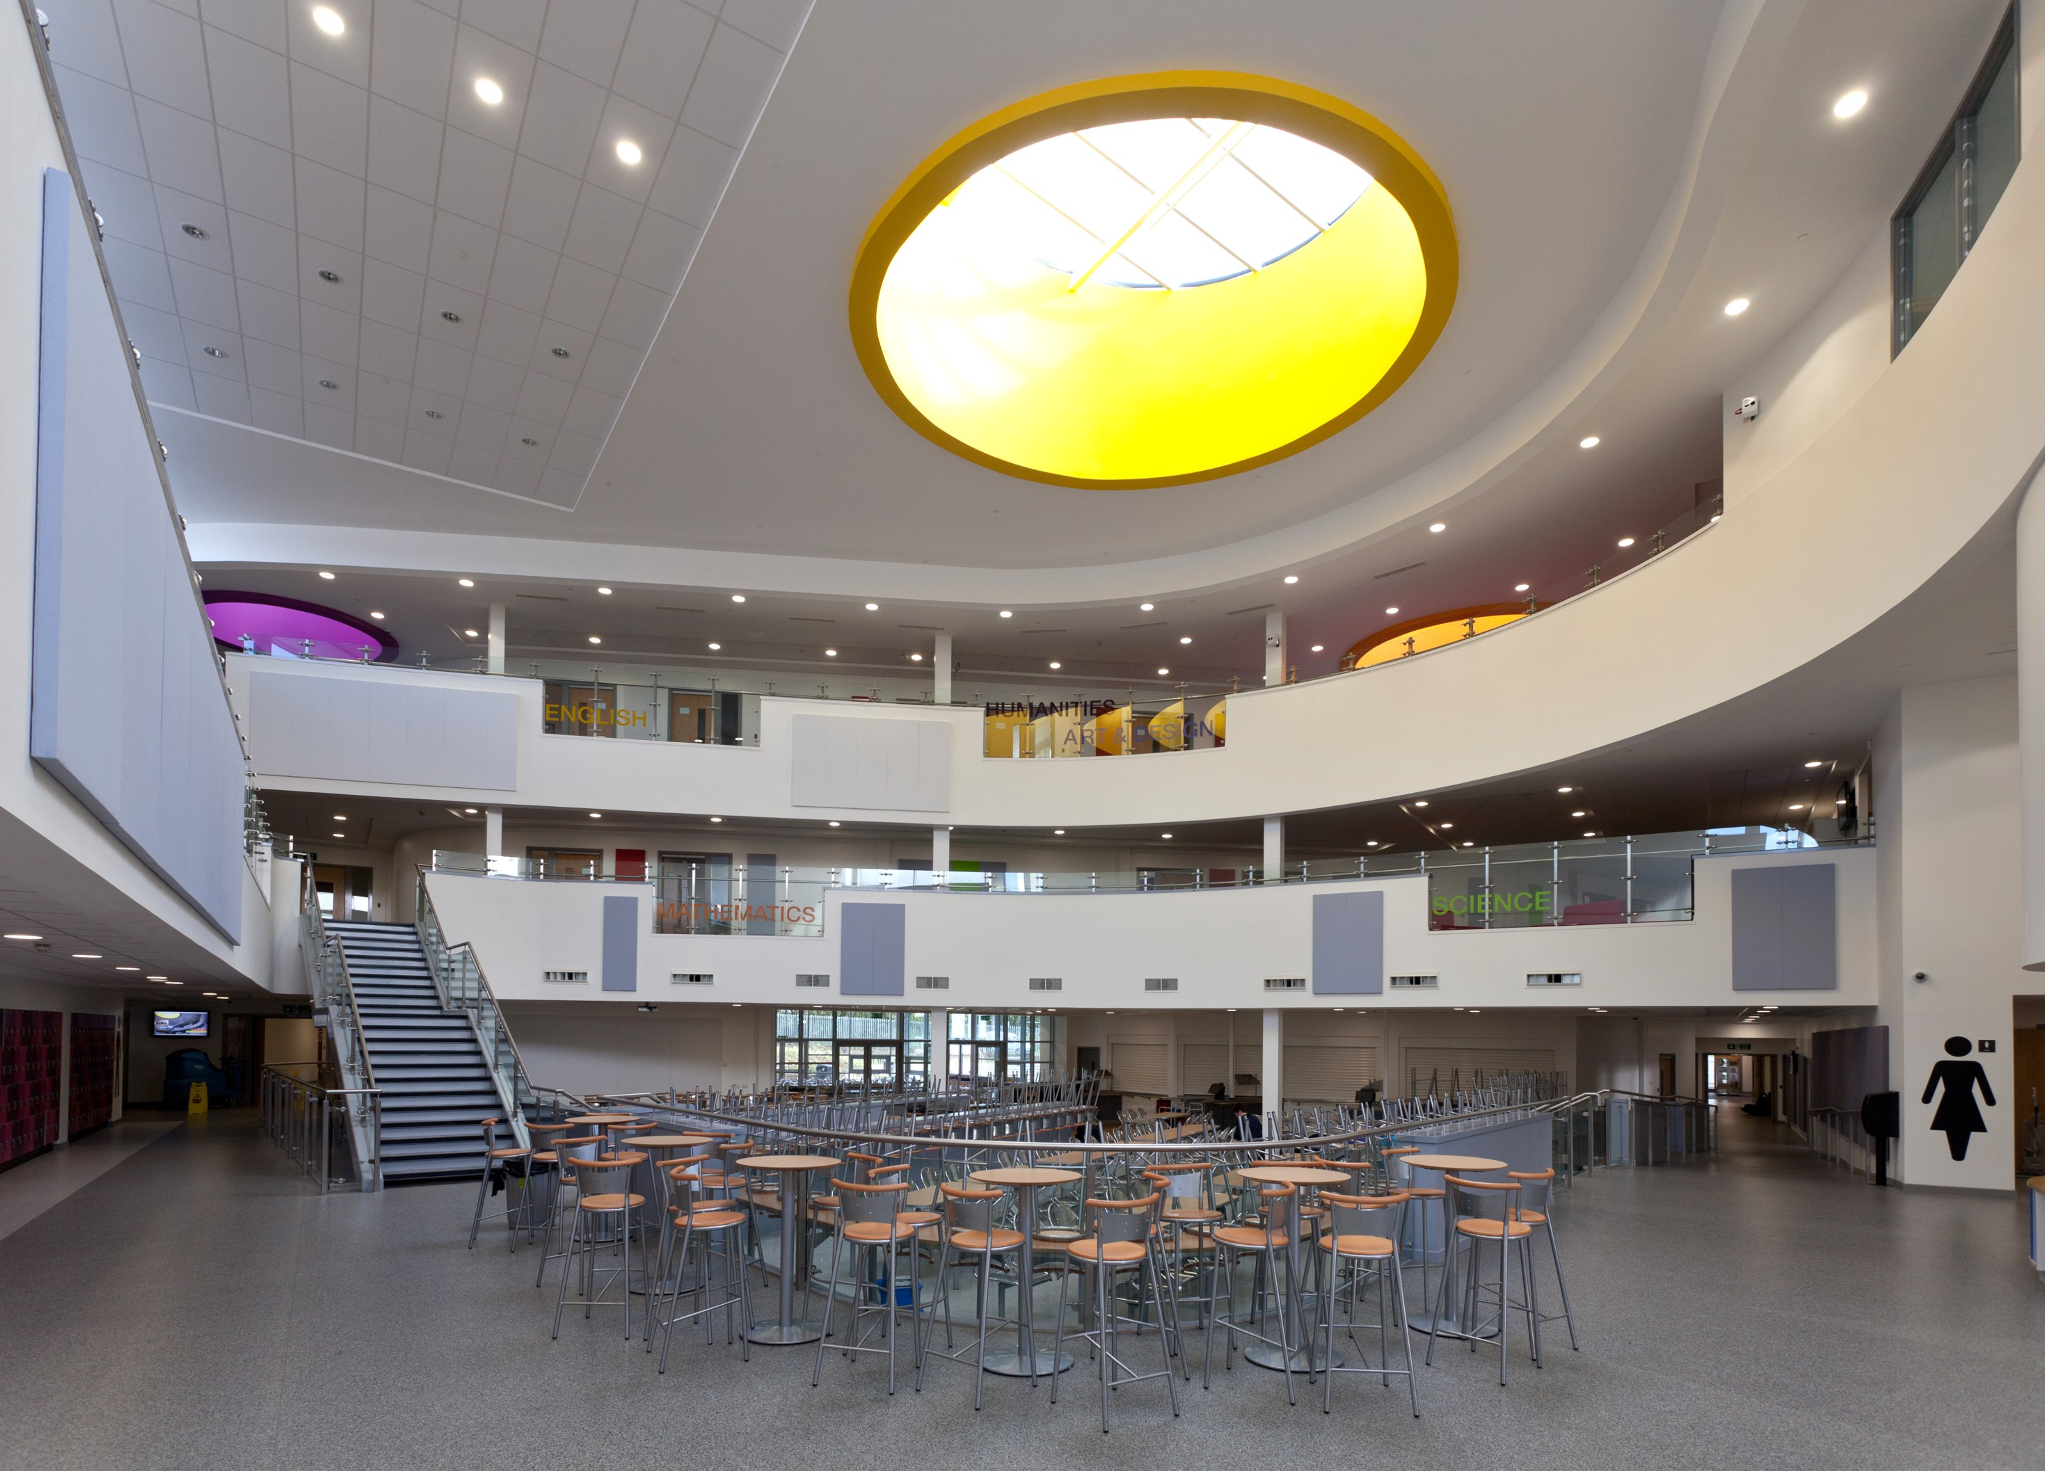
Developments must first be nominated in order
to be considered for the shortlist ; the shortlist, once
decided, will then go forward for the voting for the
People’s Award and to the judges for the other awards.
Anyone can nominate, and any development can be
nominated, provided it was completed since January
2012 or is nearing completion now.

WE ARE NOW INVITING NOMINATIONS

THESE MUST BE RECEIVED BY OCTOBER 28
2013


All kinds of developments can be considered,
From individual buildings to open space improvements, conservation initiatives or regeneration schemes. But bear in mind the judging criteria – explained overleaf.

TO NOMINATE, PLEASE FILL OUT THE ENTRY FORM OVERLEAF

Judging Criteria

The Rochdale Borough Design Award will be judged on the basis of the principles of good design as outlined in the Oldham and Rochdale Urban Design Guide Supplementary Planning Documents: The Oldham and Rochdale Urban Design Guide, the Residential Design Guide and the Public Realm Design Guide. Below is a summary of what developments should do:

Character
- respond positively to context
- respond positively to the site and contribute to a distinctive sense of place

Safety and Inclusion
- respond positively to making routes, streets and public spaces as safe and accessible as possible
- minimise opportunities for crime against car and cycle users
- minimise opportunities for crime against property and the occupants of buildings

Diversity
- incorporate a mix of uses
- provide for the needs of all sections of society
- support variety and choice in the public realm

Ease of Movement
- provide or enforce a clear network of routes
- location that supports movement by means other than the car
- priority given to the needs of pedestrians and cyclists

Designing for Future Maintenance
- think about maintenance early in the design process
- design for easy maintenance of buildings, streets and spaces

Legibility
- contribute to a legible environment
- relate positively to the visual connections between the development and its surroundings

Adaptability
- development capable of accommodating the changing and future needs of society

Sustainability

- design to reduce energy demands, including incorporating renewable energy technologies
- incorporation of measures to conserve water resources and prevent flooding
- make provision for the sustainable management and discharge of waste
- make a positive contribution to the greening of the urban environment and supporting biodiversity
- buildings that are robust, durable and age well
- construction methods and materials which contribute to the sustainable use of resources

Good Streets and Spaces
- make a positive contribution to streets and other public spaces
- make a positive contribution to the street scene
- support an attractive, pedestrian-friendly environment
- support a comfortable microclimate and protection from inclement weather

Well Designed Buildings
- contribute to a distinctive sense of place
- scale of new development should be appropriate and sensitive to its context
- form and massing should respond positively to the topography of the site, be derived from the functions of the building and create interest
- proportion should be broken down into human-scale elements to which people can relate, take cues from neighbouring buildings and the wider area and introduce appropriate vertical and horizontal rhythms
- introduce visual richness through the use of good quality materials, texture and ‘depth’

Rochdale Borough Design Awards 2013

NOMINATION FORM

Name and address of development: _____________________________________________________

__________________________________________________________________________________

Name and address of developer: _______________________________________________________

__________________________________________________________________________________

Name and Address of owner of the development, if known: __________________________________________

__________________________________________________________________________________

Your name and address: ______________________________________________________________

__________________________________________________________________________________

Your e-mail address: _________________________________________________________________

Supporting Information (why you think it’s a good design): ___________________________________

__________________________________________________________________________________

__________________________________________________________________________________

_______________________________________________(continue overleaf or on separate sheet if necessary)

This entry form and supporting information should be received by 28 October 2013.

Please send the completed entry form and any supporting information to:

Andrew Eadie
Principal Planning Officer, Strategic Planning
Directorate of Economy and Environment
Rochdale Borough Council
Number One Riverside
Smith Street
ROCHDALE
OL16 1XU
(or e-mail to andrew.eadie@rochdale.gov.uk) Questions? Call 01706 924371

