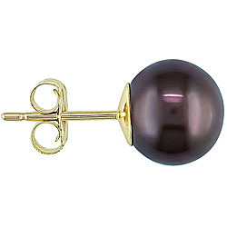
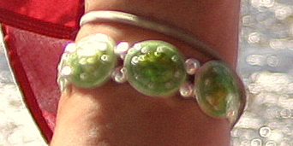

Enamel lime green bracelet


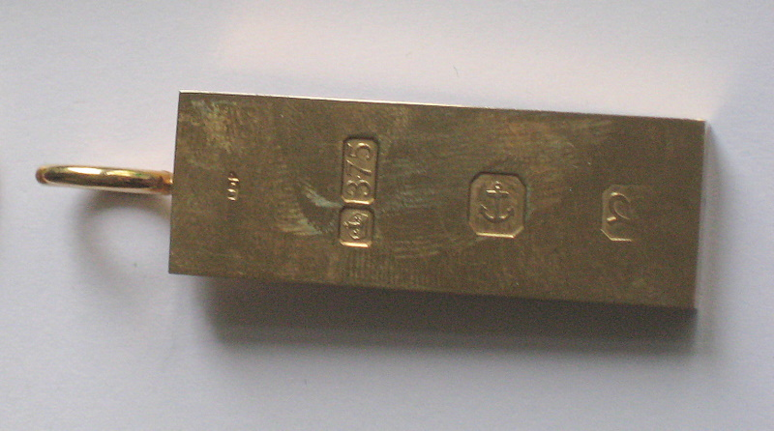

Heart Diamond stud, diamond drop, faceted Tourmaline droplet on platinum

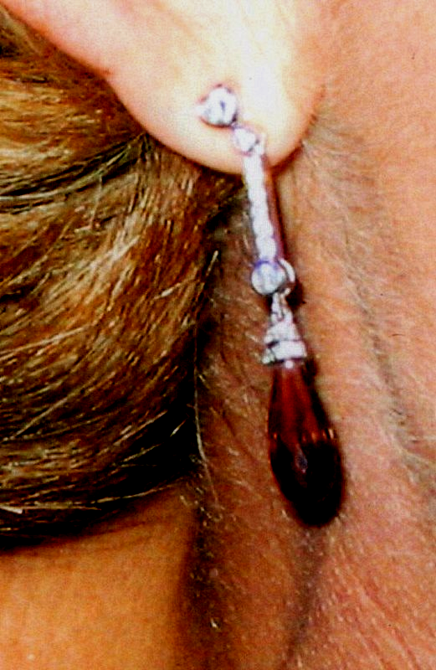
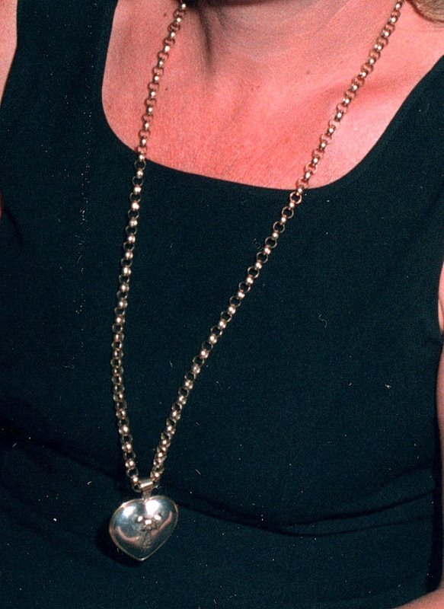

36” heavy gold belcher chain

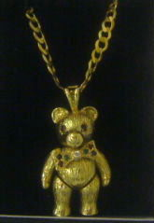

Gold jointed teddy bear pendant with ruby eyes and gold belcher chain

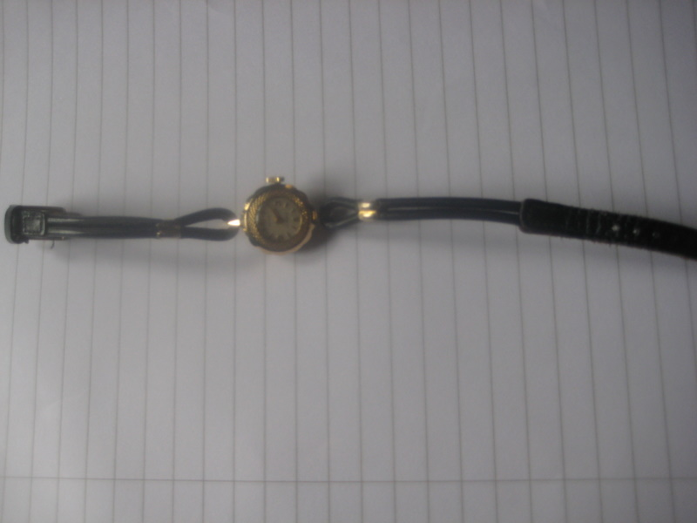

Vintage Gold ladies cocktail watch

32” fresh water pearl necklace

Black pearl earrings (pair) with gold stud.

