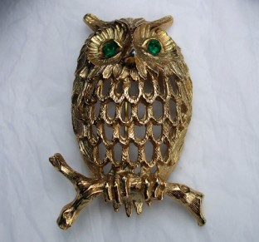

COPY IMAGE:

Solid heavy gold owl brooch with emerald eyes. NOTE not hollow like picture.

COPY IMAGE:

Mikimoto seed pearl chocker necklace with gold clasp and small seed pearl on clasp.

COPY IMAGE:

Ladies 14ct gold aquamarine oval diamond and gemstone ring

COPY IMAGE

Edwardian 9k 9ct Rose Gold Chased Curb Fancy Heart Padlock Bracelet
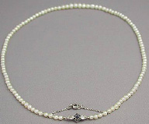
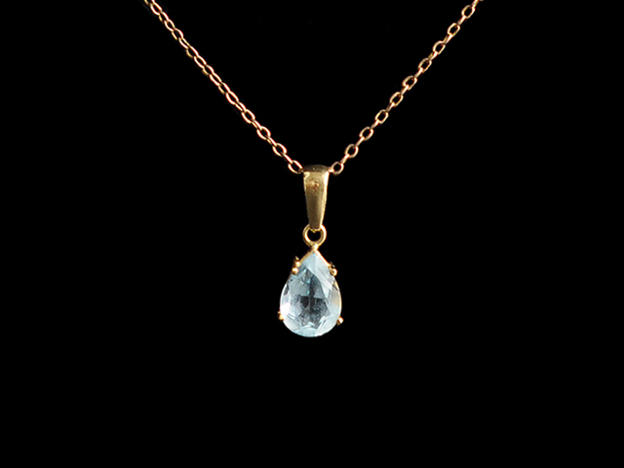
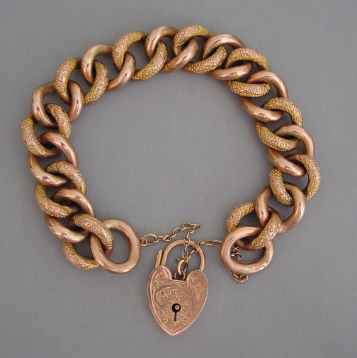
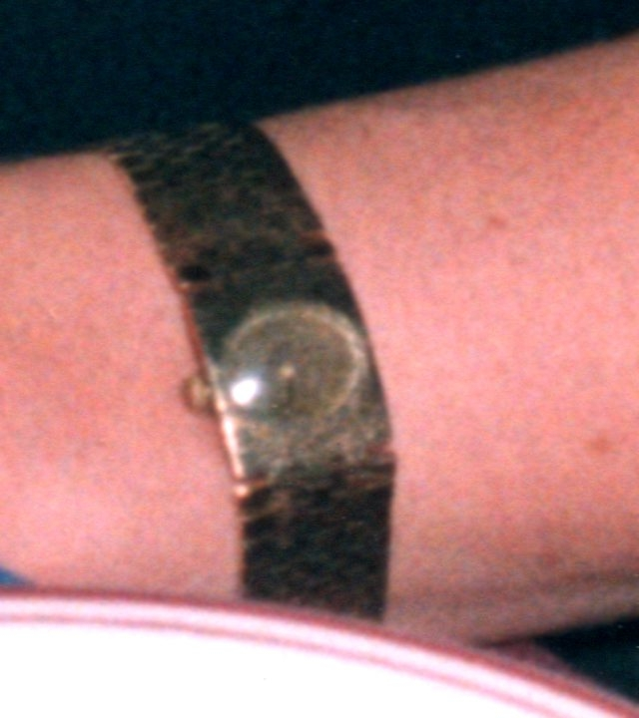

Boucheron vintage ladies gold watch with gold strap

2 Missing: 1-Purple 1 Lime
Fresh water pearls, crystals
& mother of pearl necklaces.

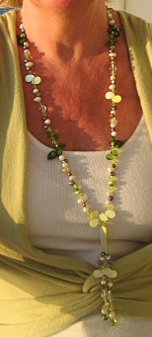
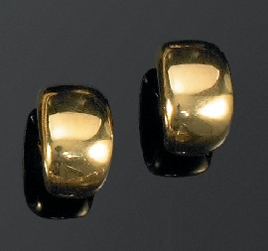

Charles Garnier Paris 18ct Yellow Gold earrings.
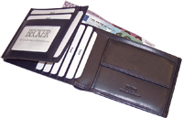

Wallet by Becker.
Black folded leather wallet

