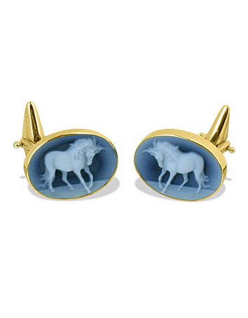
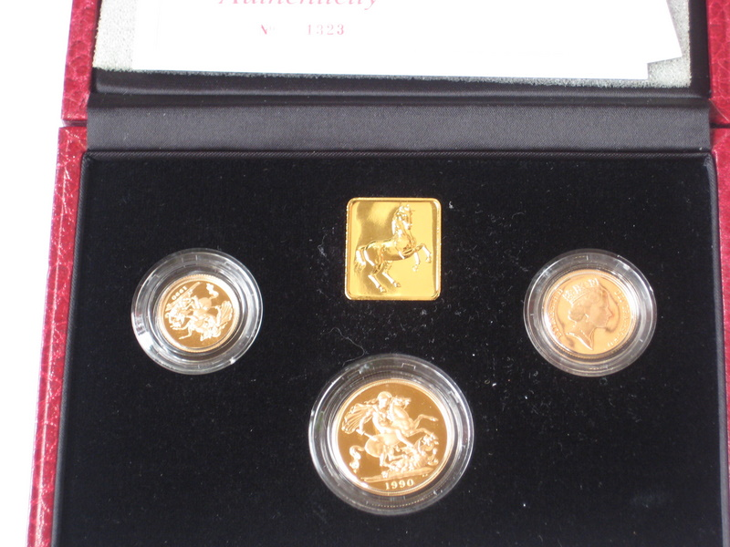

COPY IMAGE:

Royal Mint Gold proof sovereign three coin set

COPY IMAGE:

Vintage Sheaffer Gold plated fountain pen, ballpoint and pencil set in original box

COPY IMAGE:

Amber and silver bracelet

COPY IMAGE:
Real colour: PINK

Horse cameo agate 18K gold cufflinks

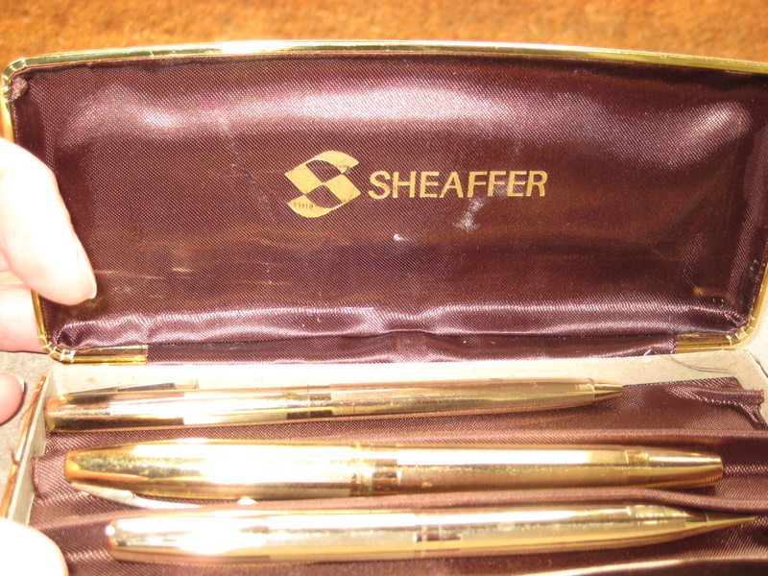
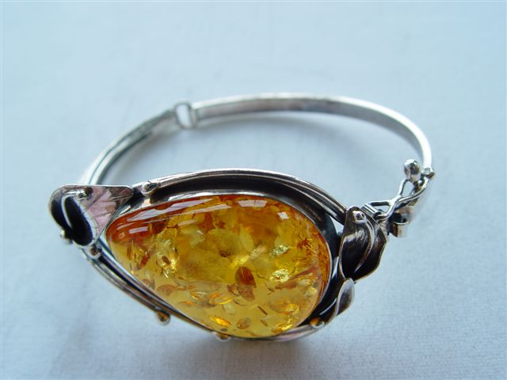
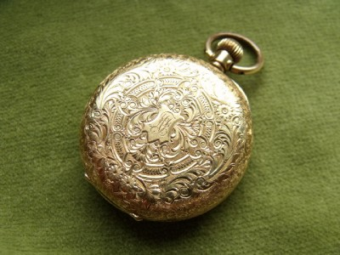

COPY IMAGE:

Ladies etched vintage 14ct gold pocket watch

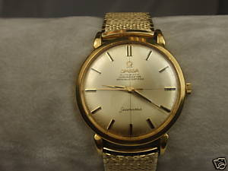

COPY IMAGE:

Vintage men’s 1965 gold Omega watch with gold strap

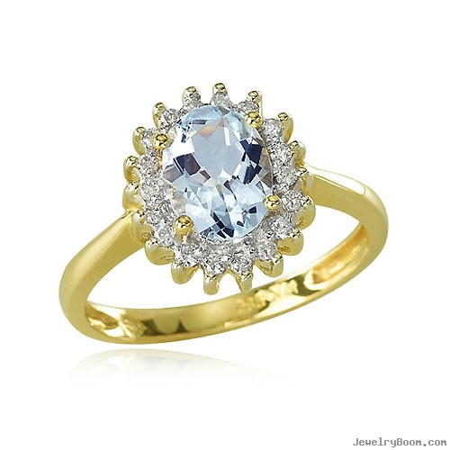

COPY IMAGE:

Ladies 14ct gold aquamarine oval diamond and gemstone ring

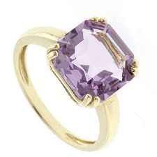

COPY IMAGE:

Alexandrite and gold cocktail ring

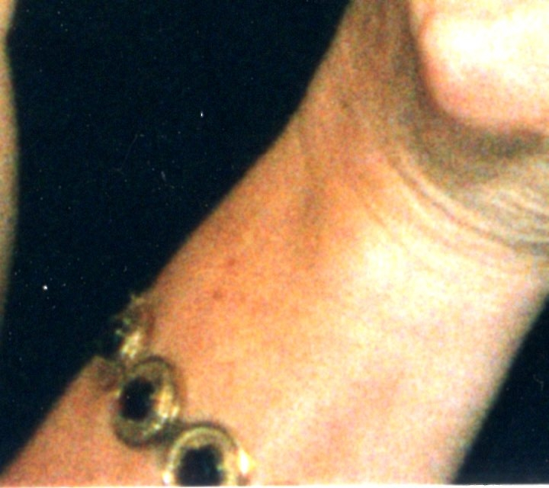

Heavy Pink gold Victorian bracelet with approx 12 large deep red garnets

