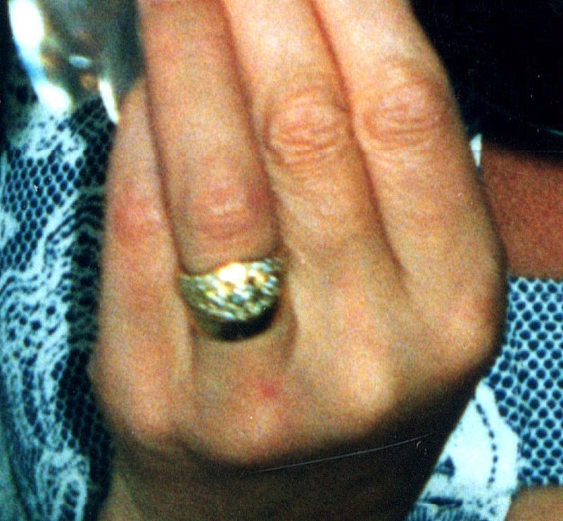

25 diamond wedding ring.
3 central diamonds surrounded by smaller diamonds set in 18ct Gold

Raymond Weil Parsifal 18ct yellow gold bezel. With yellow gold and white gold strap.

COPY IMAGE:
Item missing is bright yellow rather than blue ladies Italian enamel bracelet.

COPY IMAGE:
Ladies charm bracelet. Item missing has slightly different charms

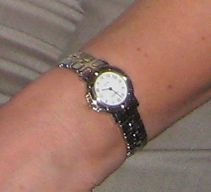
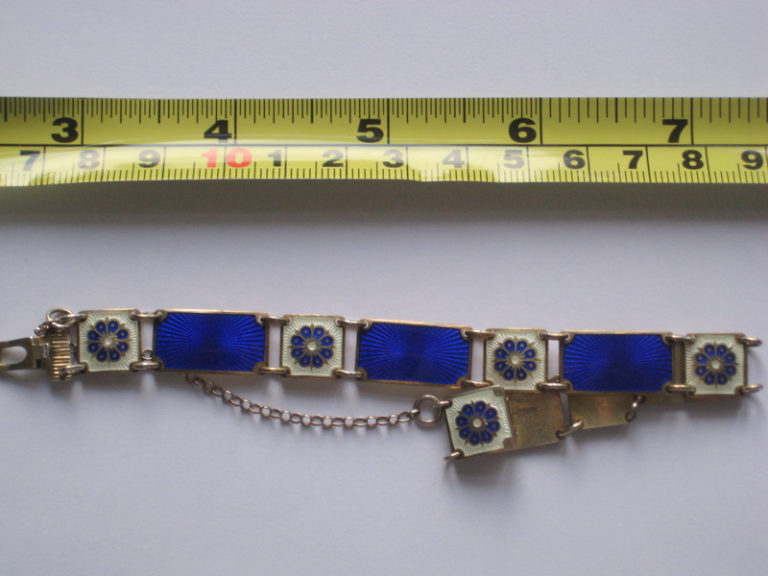
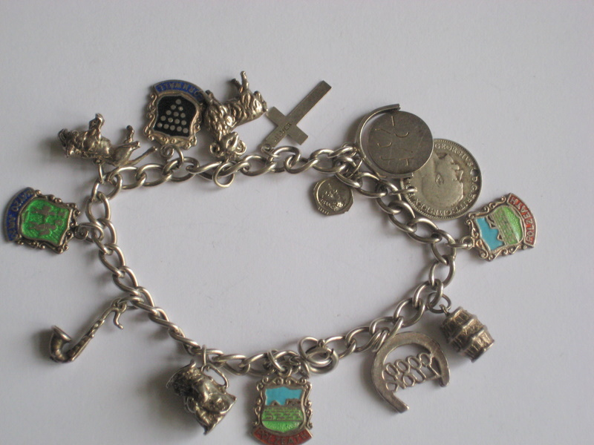
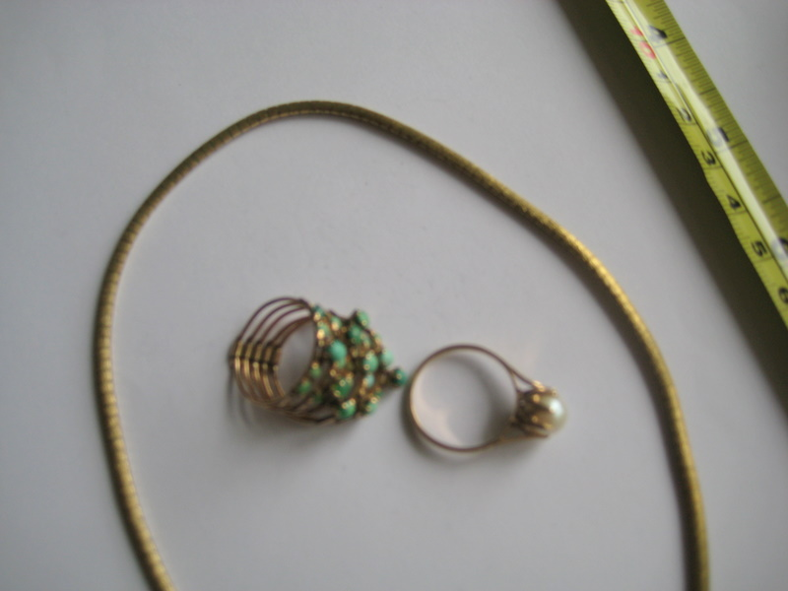
COPY IMAGE:
1. Gold solid etched chocker necklace. £180.00
2.14ct cultured pearl ring £150.00
3. Gold Harem ring with semi precious green stones £160.00

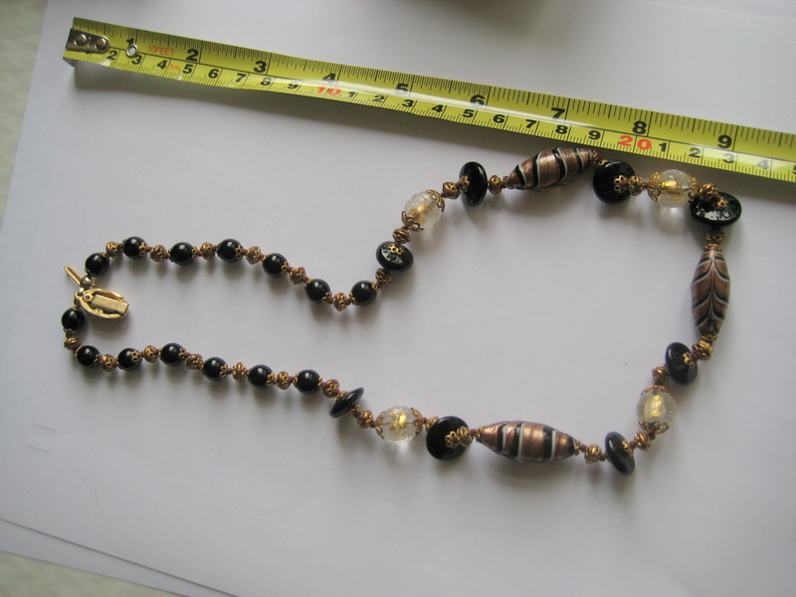

COPY IMAGE:

Murano brown and gold glass beaded necklace

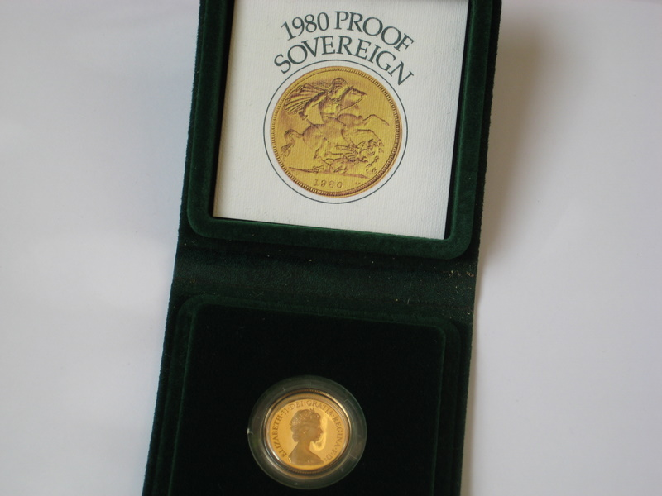

COPY IMAGE:

3 x 1980 Proof Gold sovereign in presentation box

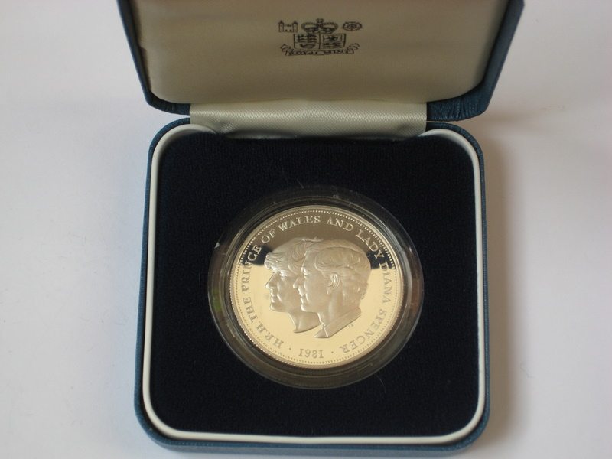

COPY IMAGE:

4x Charles & Diana silver proof sovereign

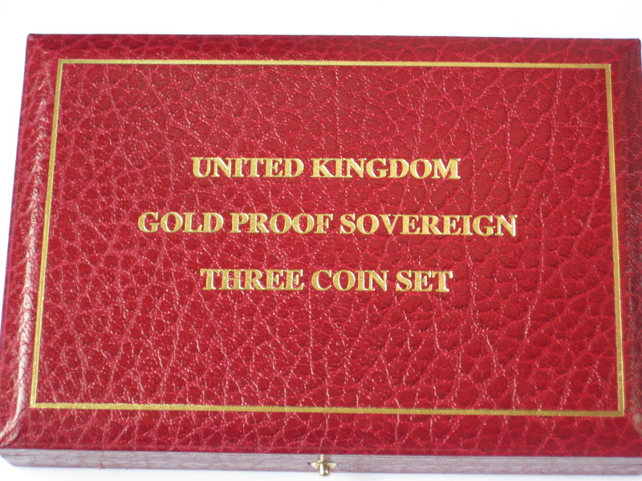

COPY IMAGE:

Royal Mint Gold proof sovereign three coin set

