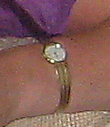

Longines ladies gold watch with gold bracelet.

Diamond Platinum Pendant. 1.07ct 16” Chain

Pink Gold vintage cocktail dress ring

Pair Platinum Diamond earrings
1.30ct each held by claw

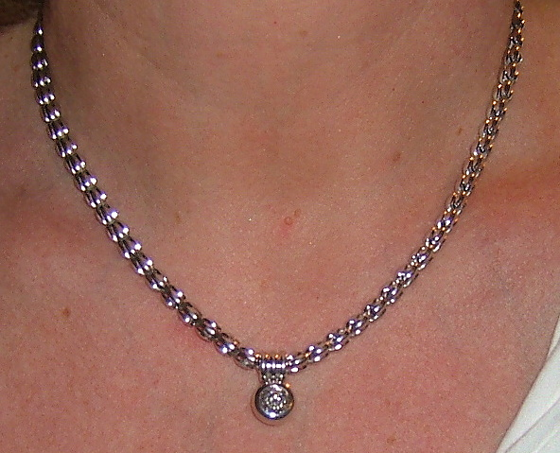
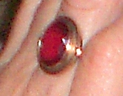
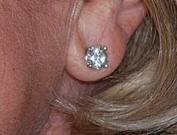
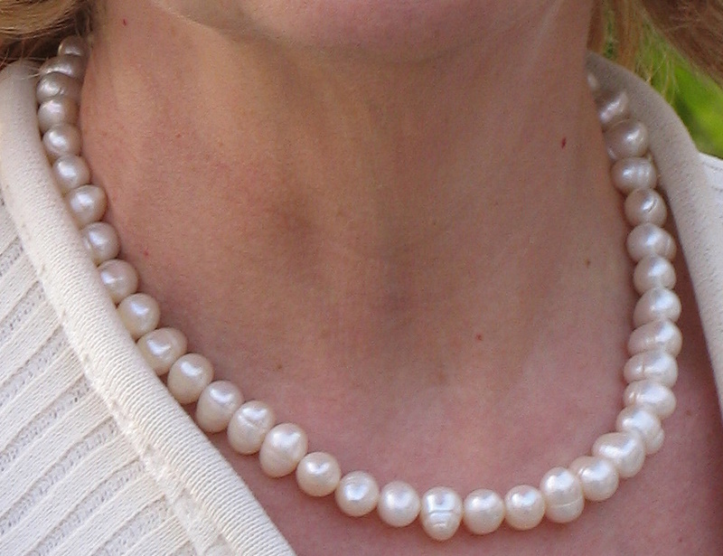

Baroque fresh water pearl necklace with gold clasp



Heart and chain both gold & white gold. Heart has small ruby’s on bow.

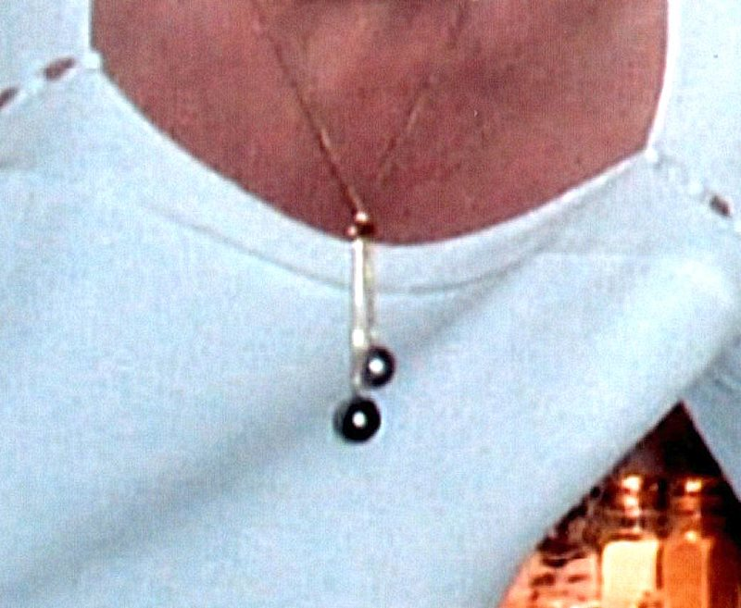

Rare colour Polynesian cultured pearls. AAA quality. On 18ct gold chain

Fresh water pearl drop earrings on gold stud

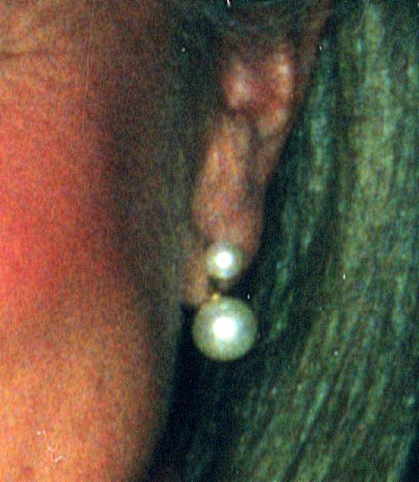

Copy image:
Lapis pearl gold bead 18” necklace

